Web Design Tasks – Exercise 3

Task 1
Download the file task1.html and create tables in it according to the shown models.
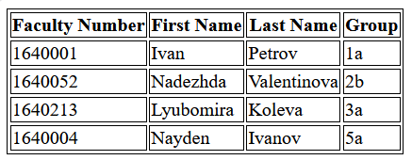
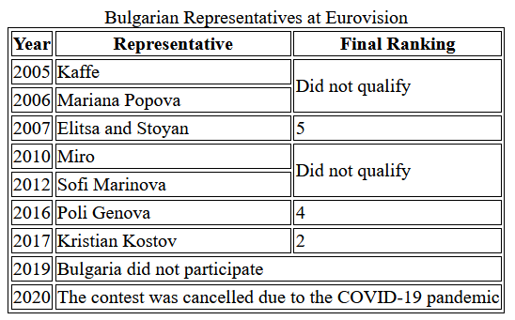
Task 2
Download the file task2.html and create the form shown below within it. Specific requirements:
- The "First Name," "Last Name," and "Password" fields must be mandatory;
- The "Password" field must display the placeholder "Please enter a password";
- The "Email" field must display the placeholder "Please enter an email";
- The "Phone" field must display the placeholder "Please enter a phone number";
- The "Spider-Man" cake must be selected by default;
- The desired frosting must be selected from a drop-down list containing the options "Fondant" "Buttercream" and " Cream" with "Cream" selected by default;
- The input field for the candle number must accept values ​​from 0 to 130;
- The text field with the default text "Enter desired inscription" must be inactive and unusable.
